BUSINESS INTELLIGENCE / PROJECT REPORT
E-Commerce Shopper
Behavior & Cart
Abandonment Analysis
A descriptive analytics review of one million synthetic shopper profiles
━━━━━━━━━━━━━━━━━━━━━━━━━━━━━━━━━━━━━━━━━━━━━━━━
BASELINE INDICATOR | EXECUTED NOTEBOOK OUTPUT
Shopper profiles | 1,000,000
Mean cart-abandonment field | 40.21%
Mean purchase-conversion field | 50.00%
Columns in supplied CSV | 60

Prepared from the executed Python notebook, the supplied MySQL analysis script, and three Power BI dashboard screenshots.
Evidence status: Python outputs were executed and are available in the uploaded notebook; MySQL script logic was reviewed but not executed against the database; Power BI screenshots were visually reviewed, but no PBIX model was supplied.

1. Executive Summary
This project examines which shopper-profile characteristics are associated with cart abandonment and purchase conversion in a synthetic e-commerce dataset. The executed notebook reports one million profiles across 60 fields, with no missing values, no exact duplicate rows, and no repeated user IDs in the checks shown.
The overall mean cart_abandonment_rate is 40.21%, while the mean purchase_conversion_rate is 50.00%. Average checkout abandonments are approximately 5.00 per shopper per month. These are averages of user-level synthetic fields; they are not event-derived website funnel rates.
Management takeaway
The strongest observed associations are between the abandonment field and the impulse-buying score (r = 0.961) and financial-decision stress (r = 0.940). The dataset description explicitly says these relationships are built into the synthetic generator. They should be treated as designed synthetic patterns, not confirmed real-world root causes.

What the evidence supports
- Mobile is the largest device segment (600,247 profiles; 60.02%) and has the highest mean abandonment field (40.23%), but its lead over desktop is only about 0.06 percentage points.
- Preferred-category averages are tightly grouped: Sports is highest at 40.30% and Books lowest at 40.11%, a spread of approximately 0.19 percentage points.
- Age and budgeting-style differences are also small; age 55–64 averages 40.28%, while age 18–24 averages 40.16%.
- Exact funnel stage conversion and abandoned-cart revenue cannot be calculated from the supplied profile fields.
Recommended management response
Treat the current dashboard as a descriptive profile-monitoring prototype. Prioritize event-level measurement, correct income segmentation, and controlled validation of mobile experience hypotheses before allocating material product or marketing investment.

2. Business Problem, Objectives and Scope
Business problem statement
The business question is whether measurable shopper attributes and summarized shopping behaviors are associated with different levels of cart abandonment in the supplied synthetic profile population, and which groups merit further investigation. The available data does not record timestamped browsing, cart, checkout and purchase events, so it cannot identify the exact point at which a shopper exits or establish why a real customer abandoned a cart.
Why this matters
A reliable abandonment analysis can help an e-commerce team decide where to improve measurement, prioritize user-experience research, and design tests. However, decisions should be driven by event-level evidence and experiments rather than small differences or relationships deliberately embedded in synthetic data.
Business questions addressed
Question | What the supplied data can answer | Important boundary
1. Funnel / drop-off | Summarize product views, average cart items, monthly abandonments and user-level rate fields. | No page-by-page event funnel or session transitions.
2. Shopper segments | Compare user-level abandonment across age and budgeting groups; inspect numeric stress and impulse scores. | Income bands must be engineered; correlations are not causes.
3. Product categories | Compare average abandonment by preferred category. | Preference is not proof of an abandoned-cart line item.
4. Devices | Compare average abandonment, conversion and session time by device. | No hypothesis test is supplied; differences are descriptive.
5. Revenue impact | Compare monthly spend and AOV between abandonment groups. | No cart value at abandonment; cannot estimate lost cart revenue.
6. Actions | Identify hypotheses for instrumentation and controlled tests. | No tested intervention or observed uplift in the supplied files.

Project objectives
- Profile shopper demographics, device mix and purchase-related attributes.
- Validate data completeness, uniqueness, field types and rate scales.
- Measure baseline user-level abandonment, conversion and shopping activity.
- Compare device, age, category and budgeting groups with sample sizes.
- Review SQL and Power BI calculations for model and aggregation risks.
- Recommend the event data needed for defensible funnel and revenue analysis.

3. Dataset Description and Data Quality
The executed notebook loaded the CSV from the Kaggle input path and reported a shape of 1,000,000 rows by 60 columns. The sample rows show one record per user_id, with demographic, financial, lifestyle and shopping-summary attributes. The dataset is explicitly described by its provider as fully synthetic.
Attribute | Observed from executed notebook
Rows / profiles | 1,000,000
Columns | 60 (the dataset page summary had previously stated 57; the actual CSV output has 60)
Data types | 45 integer columns and 15 object/text columns
Original missing values | No missing values reported in the notebook checks
Exact duplicate rows | 0
Duplicate user IDs | 0
Date field | last_purchase_date was text/object and was converted to datetime
Date range | 2025-01-01 to 2027-01-01
Rate-scale handling | cart_abandonment_rate, purchase_conversion_rate, return_rate and notification_response_rate were converted from 0–100 to 0–1 based on observed maxima

Numeric income field: important schema correction
The field income_level is an integer-valued income amount, not a pre-labelled category. In the executed notebook it ranged from 10,000 to 200,000, with Q1 = 57,466, median = 105,013 and Q3 = 152,497. The notebook grouped by exact income_level values and produced 188,991 groups, most with only one shopper. This is not a meaningful categorical breakdown.
Required dashboard correction
Create documented income bands from the numeric field (for example, sample-relative quartiles using the reported cut points) and re-run the segment measures. Do not use High / Upper-Middle / Middle / Lower-Middle / Low labels until the banding rule is implemented and checked.

Data quality interpretation
The notebook’s initial checks are unusually clean: it reported no missing values, no exact duplicate rows and no duplicate user IDs. The cleaning steps standardized column names, removed exact duplicate rows, trimmed text, converted numerical fields and parsed last_purchase_date. Since the supplied notebook output says the original fields were already fully populated, the main preparation work was type normalization and percentage-scale handling rather than imputation.

4. Tools, Methodology and Technical Review
Layer | Supplied artifact | Review status
Python / EDA | notebook1c04f5b1ed.ipynb | Executed outputs are present for loading, quality checks, summaries, segment comparisons and correlations. No raw CSV was supplied in this review to re-run independently.
SQL | E_Commerce_Shopper_Behavior_MySQL_Workbench(1).sql | MySQL 8.0+ script inspected. Query logic reviewed; it was not executed because database connection/results were not provided.
Power BI | Three dashboard screenshots and DAX block in chat | Screenshots visually reviewed. PBIX/model relationships and visual-level filters were not available for direct validation.

Python review
- The notebook has executed outputs through the export step. It loaded 1,000,000 × 60, checked duplicates/missingness, normalized four rate columns and generated basic group summaries.
- The income_level groupby is not suitable because the field has 188,991 distinct numeric values; derive income bands before comparing income segments.
- The notebook uses simple descriptive statistics and Pearson correlation. It does not perform statistical significance tests, regression, predictive modelling or A/B test analysis.
- The notebook’s revenue comparison groups profiles by abandonment rate and compares monthly_spend/AOV; this is not abandoned-cart revenue.
SQL review
- The uploaded SQL is written for MySQL 8.0+ and creates projectdata.v_e_commerce_clean without altering the base table.
- It checks row counts, types, duplicate user IDs and raw rate ranges before building a cleaned view. It normalizes rate fields and parses multiple last_purchase_date formats.
- The income/stress query groups by exact income_level and score values. Income should be banded before presentation; score grouping also requires documented bins if labels such as Low / Moderate / High are used.
- Window-function queries use RANK, DENSE_RANK and NTILE. The three Power BI summary tables cover device, category and income summary levels.
- No query result export or successful MySQL execution log was included, so SQL findings are not treated as executed evidence.
DAX review
The supplied DAX block includes KPI, segmentation, insight and data-quality measures, but is written in DEFINE MEASURE / EVALUATE query form rather than as one ordinary measure. Its rate-scale check uses the average in the active filter context, which can misread very low filtered groups when source values remain on a 0–100 scale. Normalize rates once in Power Query or determine scale from the unfiltered column maximum.

5. Baseline KPI Results
The values below are taken from the executed notebook outputs. Spend and AOV are shown in dataset units because the supplied files do not establish a currency. Rate fields are normalized to 0–1 before display.
KPI | Executed result | Definition / interpretation
Total shoppers | 1,000,000 | Distinct user_id values in the loaded profile table.
Mean cart abandonment | 40.21% | Mean of shopper-level cart_abandonment_rate field.
Mean purchase conversion | 50.00% | Mean of shopper-level purchase_conversion_rate field.
Mean monthly spend | 2,498.78 units | Average monthly_spend field; currency not confirmed.
Mean order value | 255.03 units | Average average_order_value field; currency not confirmed.
Checkout abandonments / month | 5.00 | Average checkout_abandonments_per_month per profile.
Product views / day | 25.02 | Average product_views_per_day per profile.
Cart items average | 5.49 | Average cart_items_average field.
Session minutes / day | 60.01 | Average daily_session_time_minutes field.

How to label these KPIs
Use “mean shopper-profile abandonment field” and “mean shopper-profile conversion field” in technical notes. Do not imply they are session-level rates unless the data definition confirms the denominator.

6. Finding 1 — Device Differences Are Small
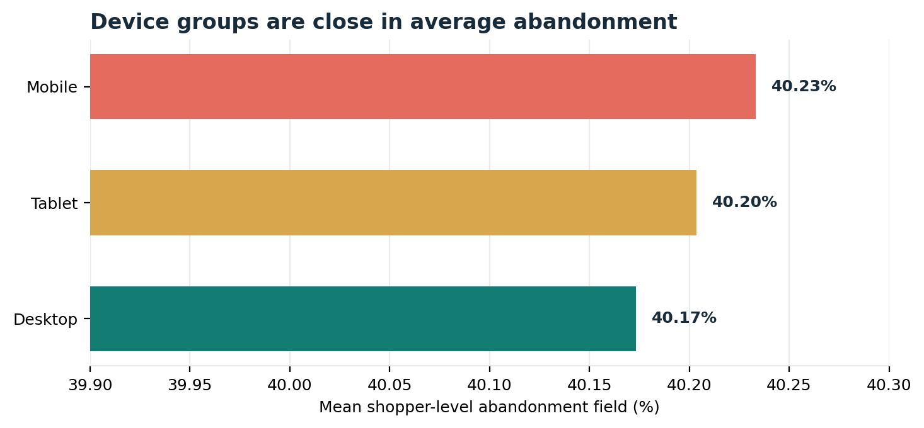
Figure 1. Mean cart_abandonment_rate by device from the executed Python groupby output.
Device | Shoppers | Share of profiles | Mean abandonment | Mean conversion | Mean session min
Mobile | 600,247 | 60.02% | 40.23% | 50.03% | 59.96
Tablet | 99,908 | 9.99% | 40.20% | 50.03% | 60.04
Desktop | 299,845 | 29.98% | 40.17% | 49.93% | 60.11

Mobile has the highest mean abandonment field, but the difference versus desktop is approximately 0.06 percentage points. Average conversion and session time are also very similar across device groups. The notebook contains no significance test, so these differences should not be described as statistically significant.
Business implication
Mobile merits a focused usability review because it represents about 60% of profiles and has the highest mean abandonment. The current evidence supports investigation—not a conclusion that mobile UX is the cause.

7. Finding 2 — Category, Age and Budgeting Effects Are Marginal
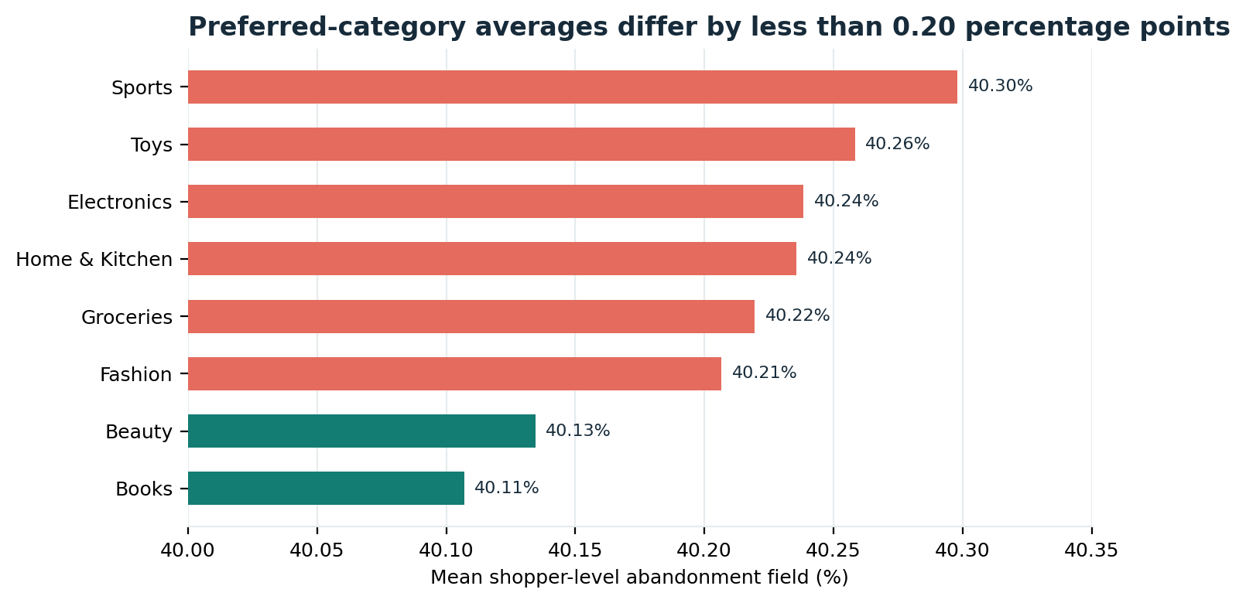
Figure 2. Mean abandonment by preferred product category. Values are user-level profile averages.
Preferred category | Shoppers | Mean abandonment | Mean AOV (units)
Sports | 125,227 | 40.30% | 255.40
Toys | 124,735 | 40.26% | 254.50
Electronics | 125,074 | 40.24% | 254.64
Home & Kitchen | 124,609 | 40.24% | 254.89
Groceries | 124,988 | 40.22% | 254.85
Fashion | 124,904 | 40.21% | 255.26
Beauty | 125,409 | 40.13% | 255.77
Books | 125,054 | 40.11% | 254.94

Sports is highest at 40.30% (125,227 shoppers), while Books is lowest at 40.11% (125,054). The range is about 0.19 percentage points. Because this is product_category_preference, it does not identify the category inside an actual abandoned cart.
Age and budgeting segmentation
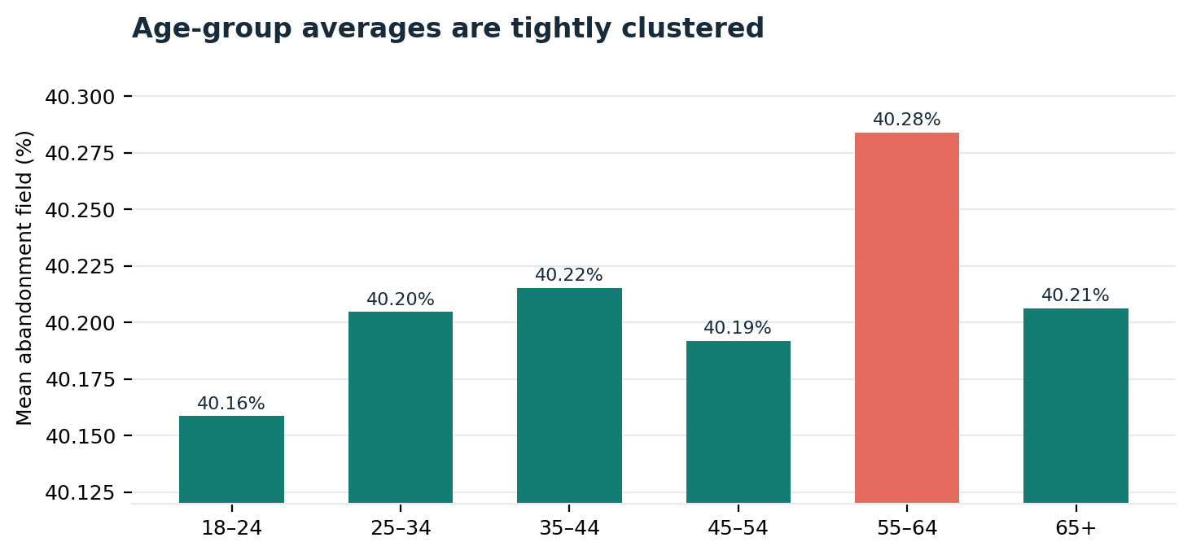
Figure 3. Age cohort abandonment averages; cohort sizes are available in the executed notebook output.
Age group | Shoppers | Mean abandonment
18–24 | 110,790 | 40.159%
25–34 | 159,052 | 40.205%
35–44 | 159,344 | 40.215%
45–54 | 158,039 | 40.192%
55–64 | 158,371 | 40.284%
65+ | 254,404 | 40.206%

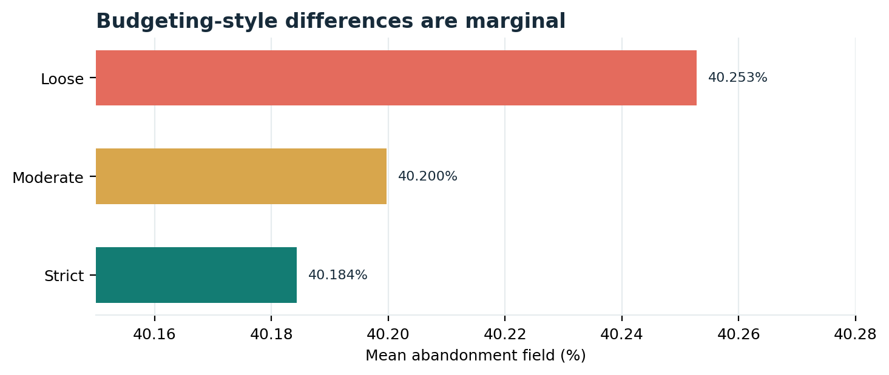
Figure 4. Mean abandonment by budgeting style.
Age 55–64 has the highest average (40.284%) and age 18–24 the lowest (40.159%), a spread of approximately 0.13 percentage points. Loose budgeting averages 40.253%, compared with 40.184% for Strict, a difference of approximately 0.07 percentage points. These are weak descriptive separations in a very large synthetic sample.

8. Finding 3 — Synthetic Behaviour Scores Carry Strong Encoded Correlation
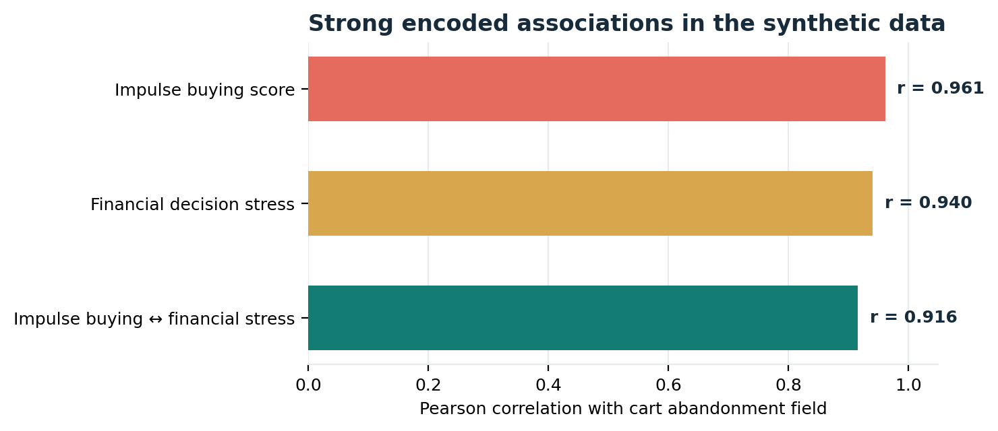
Figure 5. Pearson correlations from the executed notebook correlation matrix.
Pair of fields | Pearson r | Interpretation
Abandonment ↔ impulse buying score | 0.961 | Very strong positive association in synthetic profiles.
Abandonment ↔ financial decision stress | 0.940 | Very strong positive association in synthetic profiles.
Impulse buying ↔ financial stress | 0.916 | The two behavioural scores are themselves strongly associated.
Abandonment ↔ monthly spend | −0.002 | Essentially no linear association in this output.
Abandonment ↔ average order value | −0.001 | Essentially no linear association in this output.
Abandonment ↔ purchase conversion | 0.001 | Essentially no linear association in this output.

The dataset description says higher financial-decision stress is designed to coincide with higher impulse buying and abandonment. The observed correlations therefore reflect, at least in part, the synthetic data-generation design. They are not evidence that stress causes abandonment in real customers.
Income-level analysis must be rebuilt
income_level is numeric (10,000–200,000), with 188,991 distinct observed values. The executed notebook’s exact-value groupby is not a valid income segmentation. For an interpretable analysis, the reported sample quartiles provide possible cut points: 57,466, 105,013 and 152,497. These can define Q1–Q4 income bands, after which averages and counts must be recalculated. Existing “High / Upper-Middle / Middle / Lower-Middle / Low” screenshot values are not validated by the uploaded notebook or supplied DAX.

9. Power BI Dashboard Review
The three screenshots show a coherent three-page report with a light canvas, purple accent, left navigation and consistent slicers. Several headline KPI values are consistent with the executed Python output: 1M shoppers, 40.21% abandonment, 50.00% conversion, 25.02 product views/day, 5.49 average cart items and approximately 5 monthly checkout abandonments.
Corrections before stakeholder presentation
Dashboard element | Review finding | Required change
Page 1 trend chart | “Bookings / Shopping Activity Trend” is not supported as bookings or sales by a user-profile date field. | Remove it or re-title as shopper profiles by recorded last-purchase month; use COUNT(DISTINCT user_id), not SUM(user_id).
Income visuals and slicers | income_level is a numeric income amount, not a category; the supplied DAX has no income-band column. | Create documented quartile bands and re-run the visuals; remove the duplicate income_level slicer.
Page 2 scatter | Screenshot x-axis shows Sum of cart_abandonment_rate, which is not a meaningful predictor axis. | Use impulse_buying_score on X and mean abandonment on Y, with sensible score buckets and shopper count in tooltip.
Page 2 segment matrix | Income band labels and cell values are not reproducible from the provided notebook outputs. | Recalculate after Income Band derivation; show sample sizes.
Page 3 category donut | Visible category shares do not reconcile to the Python category counts, which are close to 12.5% each across eight categories. | Rebuild category distribution from the same `user_id` count measure.
Payment, coupon, geography | Fields exist, but these specific screenshot results are not present in the executed notebook outputs. | Re-run and export query/measure results before treating them as validated insights.
Rate formatting in DAX | Current DAX detects scale using the average in current filter context. | Normalize rates once in Power Query or base scale detection on the full unfiltered column.

Screenshot evidence
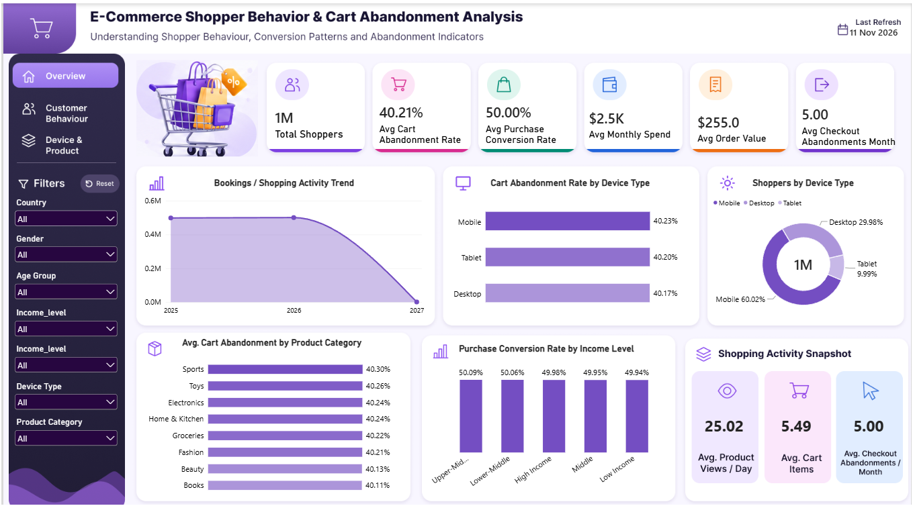
Figure 6. Page 1 — Executive Overview screenshot.
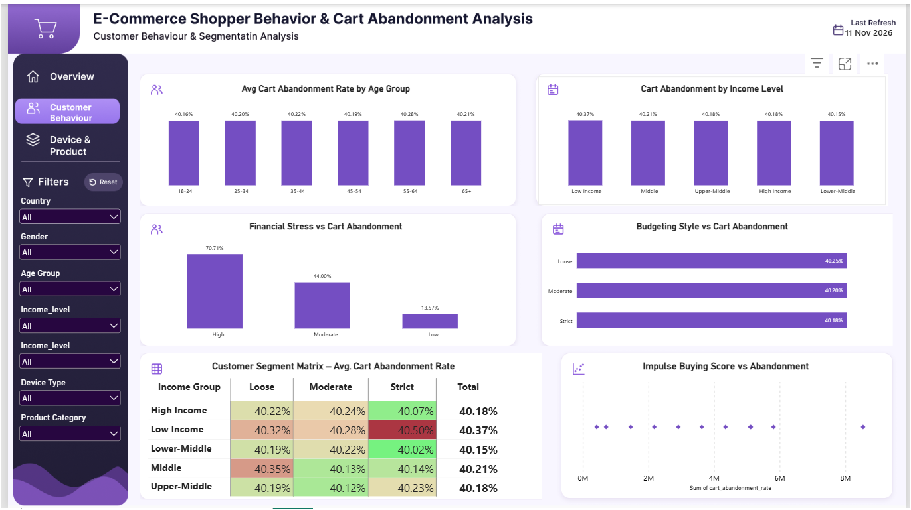
Figure 7. Page 2 — Customer Behaviour & Segmentation screenshot.
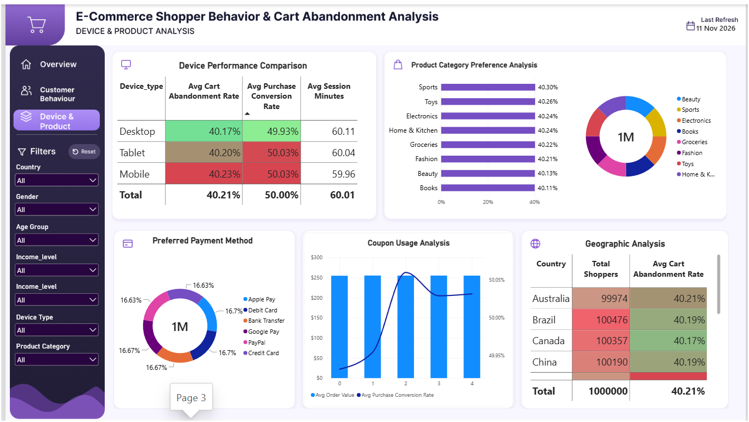
Figure 8. Page 3 — Device & Product Analysis screenshot.

10. Business Recommendations and Implementation Roadmap
Priority | Recommendation | Evidence / rationale | Monitoring
P0 — Measurement | Instrument session-level product view, add-to-cart, checkout-start, payment attempt and purchase events with session_id, cart_id, timestamps, device and cart value. | Current profile fields cannot reconstruct event sequence or abandoned-cart monetary value. | Stage conversion, checkout abandonment, abandoned cart value, event completeness.
P1 — Mobile validation | Run a mobile checkout usability review and controlled experiment. | Mobile represents 60.02% of profiles and has the highest mean abandonment (40.23%), but the device gap is only 0.06 pp. | Mobile add-to-cart-to-purchase conversion, error rate, completion time; compare treatment/control.
P1 — Income segmentation | Create quartile-based income bands using documented cut points and recalculate profile-level comparisons. | Raw income_level produces 188,991 distinct numeric values; categorical charts are currently unsupported. | Band counts, mean abandonment and conversion with sample size.
P2 — Behavioral hypotheses | Validate impulse buying and financial-stress relationships on real, consented behavioral data; avoid causal or sensitive targeting claims. | Correlations are very high but the dataset provider documents built-in synthetic correlations. | Replicated correlations, model stability, fairness/privacy review.
P2 — Category prioritization | Do not prioritize a category based only on the current small differences; inspect real cart-line items and test category-specific friction. | Preferred-category abandonment spans only about 0.19 pp. | Cart-line item abandonment by category, with adequate sample sizes.
P2 — Payment/coupon/geography | Rebuild these visuals from validated SQL/PBI output and assess denominator consistency before action. | Screenshots show these dimensions, but executed Python summary evidence was not provided for them. | Conversion by payment/coupon, country sample size, data-quality checks.

Proposed 30–60–90 day sequence
Horizon | Workstream | Deliverable
0–30 days | Data and semantic-model validation | Rebuild income bands, fix DAX rate scaling, correct dashboard aggregations, reconcile category counts, and document KPI definitions.
31–60 days | Event instrumentation and UX discovery | Implement event/session/cart telemetry and conduct mobile checkout usability review.
61–90 days | Controlled tests and reporting | Run controlled experiments, report treatment effects with confidence intervals, and scale only changes supported by evidence.

11. KPI Monitoring Plan, Limitations and Conclusion
Recommended KPI definitions after event instrumentation
KPI | Recommended event-level definition
Product-view-to-cart rate | Sessions with add_to_cart ÷ sessions with product_view.
Cart-to-checkout rate | Sessions with checkout_start ÷ sessions with add_to_cart.
Checkout completion rate | Sessions with purchase ÷ sessions with checkout_start.
Cart abandonment rate | Sessions with add_to_cart and no purchase within the agreed attribution window ÷ sessions with add_to_cart.
Checkout abandonment rate | Sessions with checkout_start and no purchase within the agreed attribution window ÷ sessions with checkout_start.
Abandoned cart value | Sum of item prices and quantities in qualifying abandoned carts; define treatment of tax, shipping and discounts.

Limitations and assumptions
- The data is synthetic; findings describe the generated profiles, not observed customers on Amazon, Shopify or any actual merchant platform.
- There is no raw CSV in the current attachment set. Numeric results are taken from executed outputs embedded in the uploaded notebook and were not re-run independently in this review.
- The MySQL script was reviewed but not executed against the database. Query results and performance are therefore unverified.
- The PBIX file was not supplied. DAX formulas were reviewed from the text in the conversation; model relationships, interactions, visual filters and refresh configuration could not be inspected.
- The source does not specify a currency for monthly_spend or average_order_value; no currency symbol is applied.
- No hypothesis tests, causal analysis, predictive model or experiment results were supplied.
- Some dashboard visuals are not reconciled to the notebook outputs and should be corrected before stakeholder use.
Conclusion
The executed analysis establishes a clean, large synthetic profile dataset and a stable descriptive baseline: mean abandonment is 40.21%, mean conversion is 50.00%, and mean monthly checkout abandonments are about five per profile. Device, age, budgeting and preferred-category differences are modest. Strong correlations with impulse-buying and financial-stress scores are consistent with the dataset’s stated synthetic design and should not be presented as verified real-world causes.
The strongest management decision is to close the measurement gap: add event-level journey and cart-value data, repair income segmentation and dashboard aggregations, and then validate mobile and behavioral hypotheses with controlled tests. The current report is suitable as a synthetic-data analytics case study when its limitations are clearly disclosed.
Evidence register
Finding | Source / location | Status
1M rows × 60 columns; no missing / duplicates | Executed notebook cells 4, 6, 8, 18 | Executed output available; not independently rerun here.
Rate fields scaled from 0–100 to 0–1 | Notebook cell 16 | Executed output available.
Overall KPIs and activity means | Notebook cells 18 and 22 | Executed output available.
Device, category, age and budgeting results | Notebook cells 24, 26 and 28 | Executed groupby outputs available.
Abandonment correlations | Notebook cell 34 | Executed Pearson correlation matrix available.
SQL transformations and summaries | MySQL SQL script sections 1–4 | Logic reviewed; not executed.
Dashboard values and visual design | Three screenshots uploaded 11 Nov 2026 | Visually observed; no PBIX verification.

